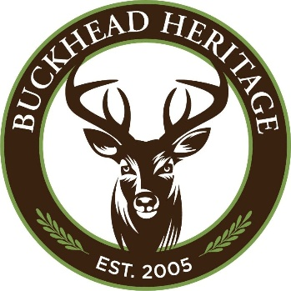

March 2026 Newsletter

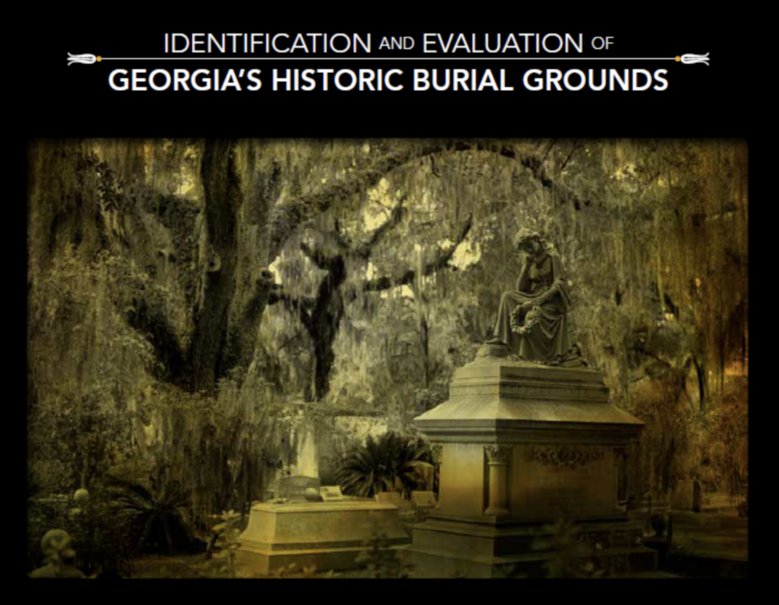

Speaker Series: What Georgia’s Cemeteries Tell Us About Who We Are
Julie Coco, Director of History New South Associates
Thursday, March 26, 2026, 7 p.m., Free Cathedral of St. Philip, Gould Room

Register

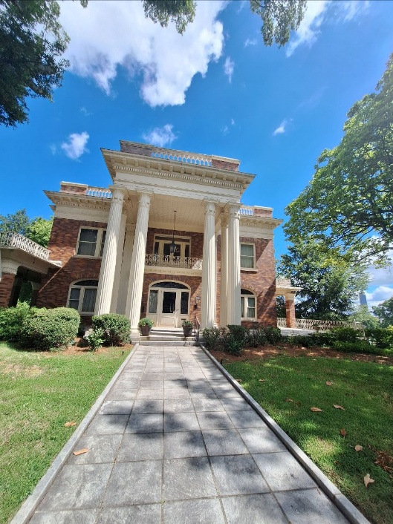

Speaker Series: Mary Ilonah will focus on “The Herndon Family Legacy: Building Institutions and Men Before the Civil Rights Movement.”

Thursday, April 23, 2026, 7 p.m., Free
Cathedral of Saint Philip Gould Room
This talk will explore how the Herndon family’s visionary work in business, education, and community development helped shape the social and economic foundations that later sustained the Civil Rights Movement in Atlanta and beyond. Drawing from archival materials and museum interpretation at the Herndon Home Museum, Mary will highlight how Alonzo, Adrienne, Jessie, and Norris Herndon’s leadership and philanthropy nurtured generations of Black excellence, dignity, and self-determination. May Ilonah is Museum's Operations Manager at the Historic Herndon Home Museum in Atlanta.
Register

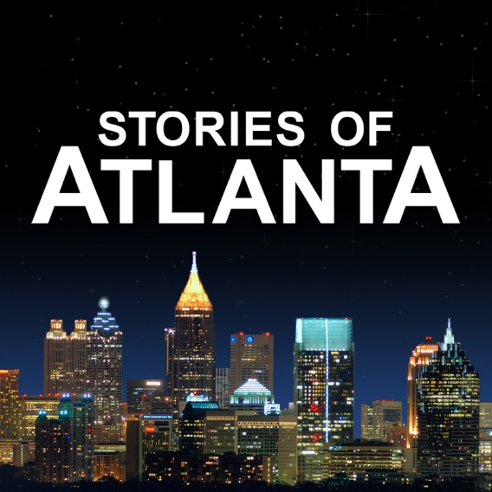

Speaker Series: Filmmaker Lance Russell, creator of the Stories of Atlanta YouTube channel, reveals new dimensions of a city many think they already know.
Thursday, May 28, 7p.m., Free
Cathedral of Saint Philip Child Hall

Atlanta’s history is often told through a familiar set of names, events, and landmarks, yet the city’s past extends far beyond William Sherman, Scarlett O’Hara, Coca-Cola, and a really busy airport. In a visually immersive presentation, Lance draws from the extensive archive of his Stories of Atlanta videos to veer off the beaten path and explore the surprising, quirky, and often overlooked moments tucked into Atlanta’s forgotten corners.

You may know Atlanta’s story, but do you know the rest of the story?
Register

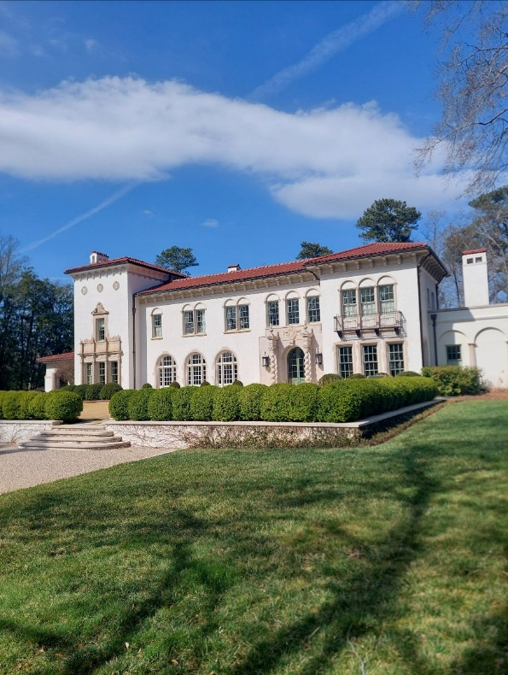

SAVE THE DATE
2026 House and Garden Party
We are excited to announce our House and Garden Party, Sunday, May 17, from 4:00 p.m. to 6:30 p.m. We will carry on our tradition of cocktails, buffet, and music in the home and garden of Frances and Robin Loudermilk, Villa Juanita, West Paces Ferry Road.
The grandeur of Villa Juanita began with the roaring ‘20s when Conkey P. Whitehead purchased this land for his new bride, Julia Murphy. The Whitehead family had made their fortune by obtaining exclusive rights to bottle and sell Coca Cola in 1889. They built Villa Juanita in 1922 to host their active social life.
More details will follow shortly.

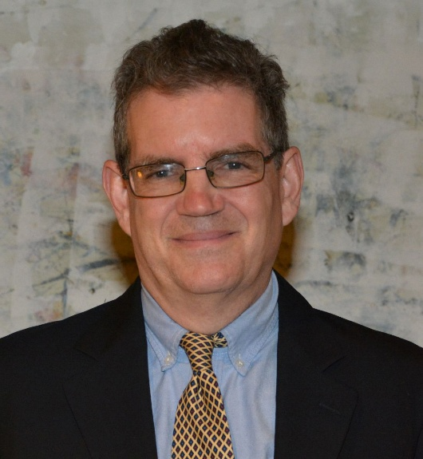

Executive Director's Report
Our membership renewals and new members were very strong for both January and February. Please join us a new member and make March as strong as the last 2 months.
We are excited that our Peachtree Heights East Walking Tours that are a part of the outstanding Atlanta Preservation Center's Phoenix Flies, are sold out. We will be offering the walking tours again in May, July, September, and November. The tours will be listed in future newsletters.
If you haven't been to one of our programs at The Cathedral of Saint Philip, please consider coming. They are always incredibly informative. We also offer free wine, beer, water, and snacks.
Take care,
Richard Waterhouse

To Join or Renew Buckhead Heritage
Membership
Go Here or contact Richard Waterhouse at (404) 467-9447, or email rwaterhouse@buckheadheritage.com.

Buckhead Heritage Mission Statement
Buckhead Heritage strives to enhance the quality of life in Buckhead by identifying, preserving, and promoting its historic resources.
We endeavor to foster a conscious respect within the community for its rich and diverse history, ensuring that Buckhead’s historic resources are accommodated in future growth and secured for the benefit of the community.

2026 Board & Staff  Officers  Thornton Kennedy - President  Judith Vanderver - Vice President  Frank W. Virgin - Secretary  Michael Armstrong - Treasurer  Ivan Allen, IV - Past President  Board of Directors  Beckie Amos  Barbara Bazzel  Howard Benson  Lisa L. deGolian  Carol C. Grady  Chris Hastings  Alec Michaelides  Christy Morris  Elon Butts Osby  James M. Ottley  Elizabeth Morgan  Spiegel  Mary Anne Walser | Emeritus Board  Tamara A. Bazzle  John Beach  Wright Mitchell, Founder  E. Fay Pearce, Jr.  Executive Director  Richard Waterhouse

Our contact information:
Buckhead Heritage, 3180 Mathieson Drive, Suite 200, Atlanta, GA 30305
(404) 467-9447
info@buckheadheritage.com
Buckheadheritage.com

